- spring-data-jpa-handson
Spring Data JPA - Quick Example:
Employee.java:
package com.employeespringdatajpa.model;

import jakarta.persistence.*;

@Entity
public class Employee {
@Id
@GeneratedValue(strategy = GenerationType.IDENTITY)
private Long id;

private String name;
private String role;
public Long getId() {
return id;
}
public void setId(Long id) {
this.id = id;
}
public String getName() {
return name;
}
public void setName(String name) {
this.name = name;
}
public String getRole() {
return role;
}
public void setRole(String role) {
this.role = role;
}

}
EmployeeSpringDataJpaApplication.java:
package com.employeespringdatajpa;

import org.springframework.boot.SpringApplication;
import org.springframework.boot.autoconfigure.SpringBootApplication;

@SpringBootApplication
public class EmployeeSpringDataJpaApplication {
public static void main(String[] args) {
SpringApplication.run(EmployeeSpringDataJpaApplication.class, args);
}
}
EmployeeRepository.java:
package com.employeespringdatajpa.repository;

import org.springframework.data.jpa.repository.JpaRepository;

import com.employeespringdatajpa.model.Employee;

public interface EmployeeRepository extends JpaRepository<Employee, Long> {
}
EmployeeController.java:
package com.employeespringdatajpa.controller;

import com.employeespringdatajpa.model.Employee;
import com.employeespringdatajpa.repository.EmployeeRepository;

import org.springframework.beans.factory.annotation.Autowired;
import org.springframework.web.bind.annotation.*;

import java.util.List;

@RestController
@RequestMapping("/employees")
public class EmployeeController {

@Autowired
private EmployeeRepository repository;

@PostMapping
public Employee saveEmployee(@RequestBody Employee emp) {
return repository.save(emp);
}

@GetMapping
public List<Employee> getAllEmployees() {
return repository.findAll();
}
}

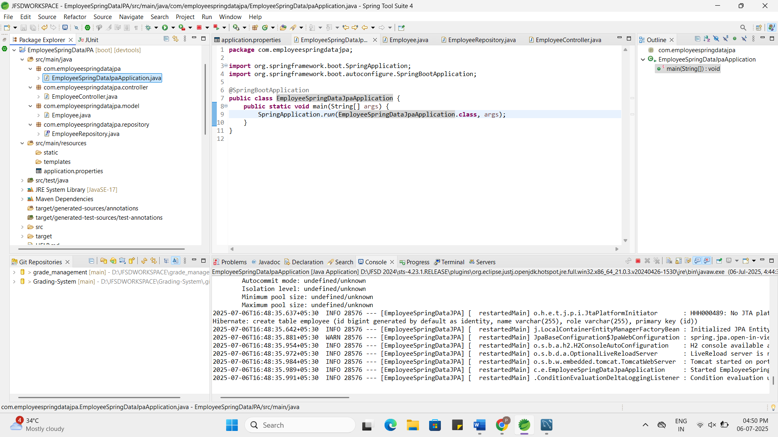

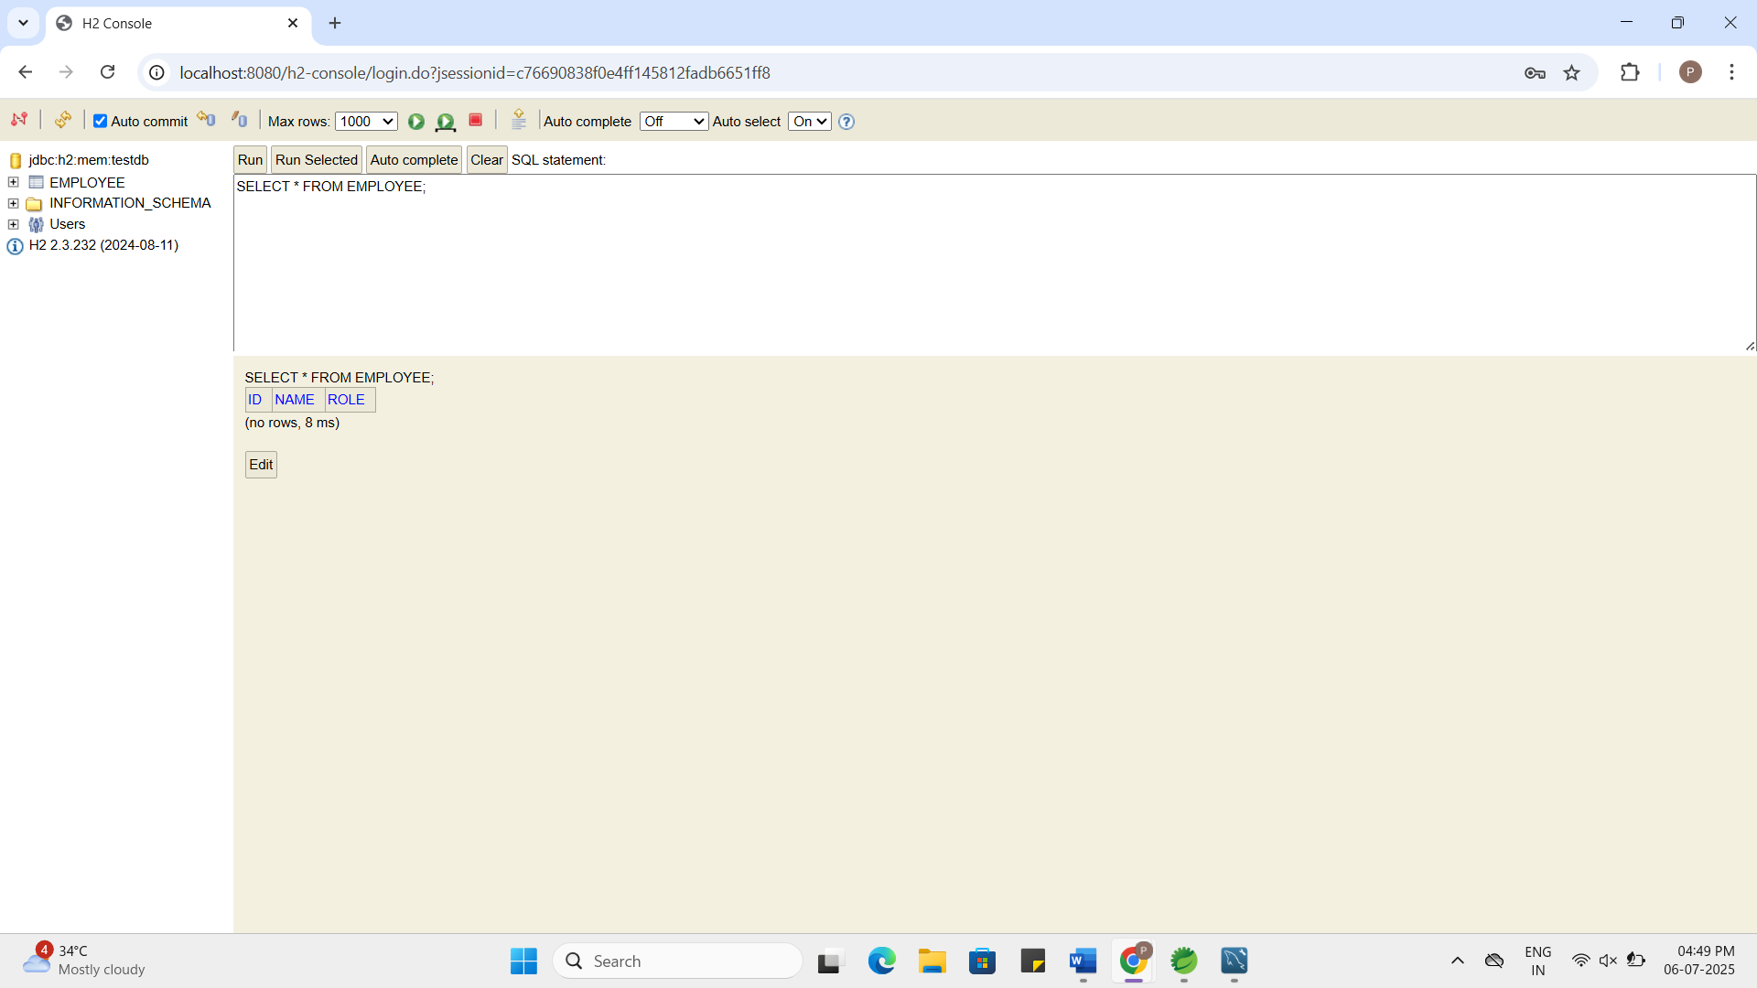

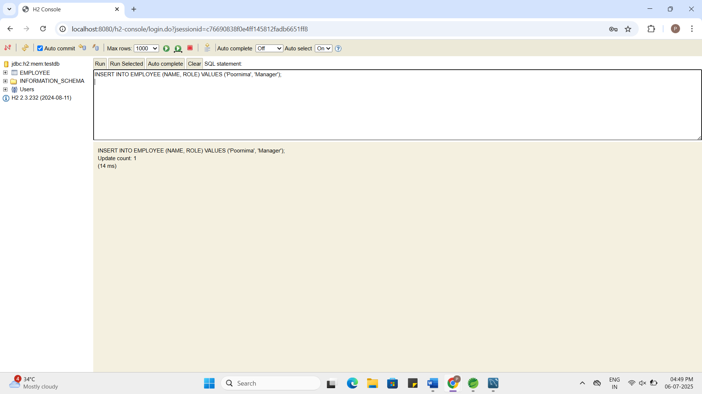

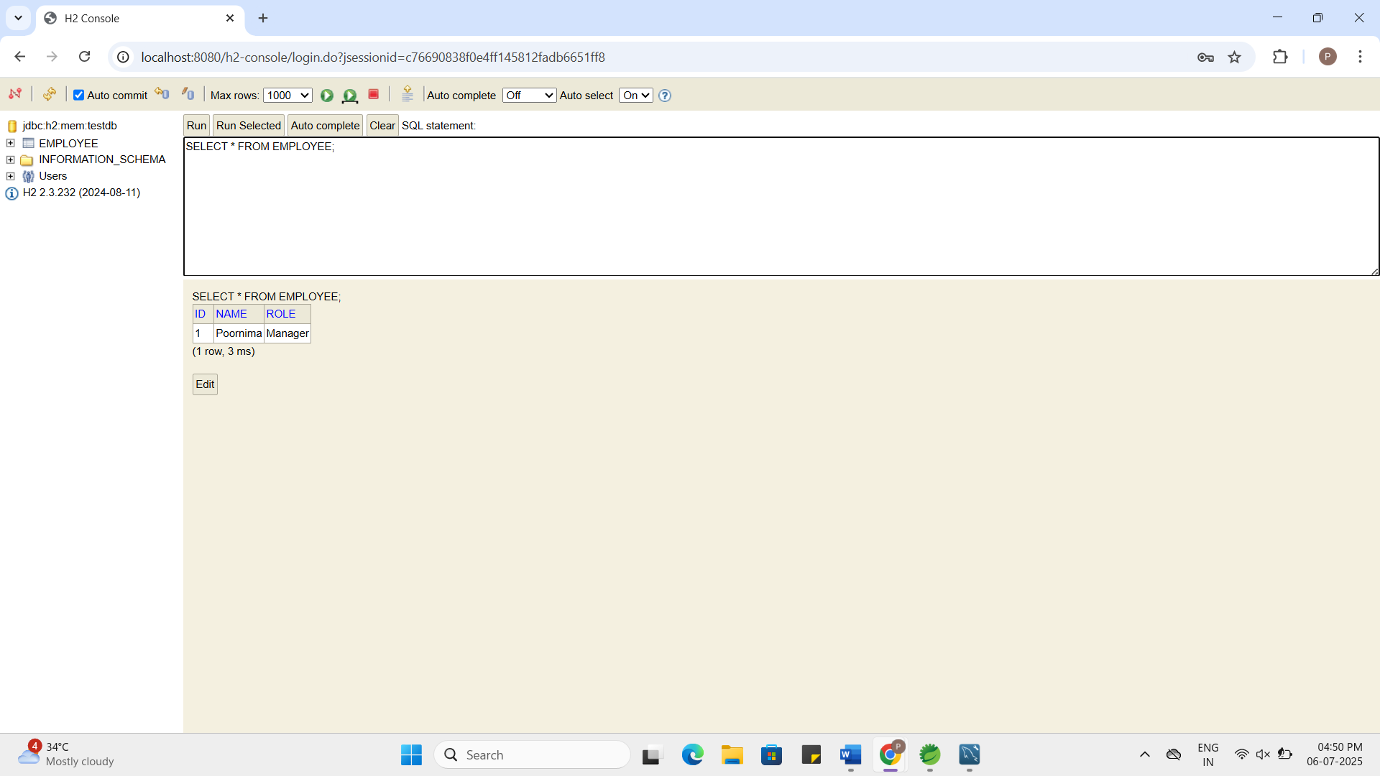

- spring-data-jpa-handson
Difference between JPA, Hibernate and Spring Data JPA:
- JPA is just a set of rules (a specification) for how Java should work with databases.
- Hibernate is a tool (implementation) that follows those JPA rules and actually does the work.
- Spring Data JPA builds on top of JPA and Hibernate to make things even easier.
- With JPA, you write more code manually (like EntityManager).
- With Hibernate, you get more features, but still manage queries yourself.
- With Spring Data JPA, you just write an interface, and Spring creates all the database code for you automatically.
- It helps save time and reduces boilerplate code.

